

**HERBS**

Do you want your own herb garden but not sure how to go about it? Don’t worry - herbs are ideally suited to growing in a garden4me raised planter. Herbs are aromatic, attractive and have many uses from cooking to herbal teas and summer drinks. You can have your own year round supply, saving money on expensive supermarkets. Here’s our garden4me guide to creating your own herb garden, our recommendations for what to grow and tips on preserving what you’ve grown - from drying and freezing to creating your own aromatic oils .

The unique features of the garden4me raised planter make it the perfect place to grow herbs. The built-in self-regulating reservoir will keep your plants hydrated but not water-logged as they take up just as much water as they need – ideal for herbs as you can mix those that like plenty of water such as chives and mint with those that like drier conditions - such as rosemary and thyme.

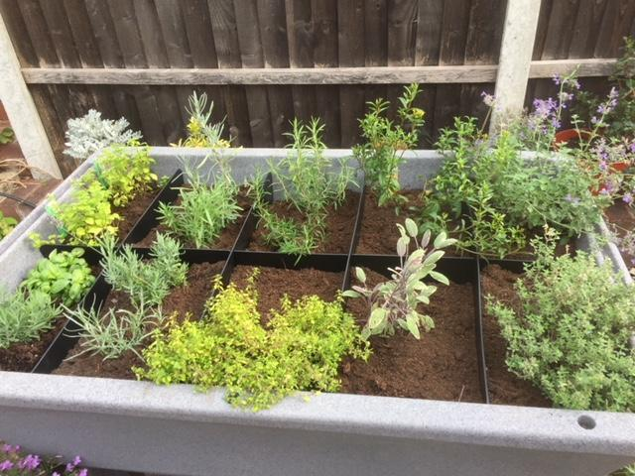

The 10 inch growing bed gives plants a deep root run and although herbs such as mint can be invasive, by using garden4me growing pockets you can limit the spread of the more vigorous plants.

And don’t forget the garden4me raised planter is made from food-grade certified material so there is no risk of toxins leaching into your herb crops.

The double-walled construction with its insulating air-gap keeps roots protected from the frost – so herbs such as mint, rosemary, thyme and sage can live outside all year.

**Getting to know your herbs**

**There are broadly three main groups of herbs which all need handling a bit differently …**

**Evergreen Mediterranean herbs** - such as rosemary, sage and bay and all the various lavenders and thymes, are technically hardy but they hate wet feet which is why they’ll thrive in our planters as they won’t get waterlogged.

**Traditional English-style hardy perennial herbs** - such as chives, mint and tarragon like to be kept in a wetter compost so the built-in reservoir works for them as they will keep drinking what they need and won’t dry out. These herbs will die down for the winter – they are true herbaceous perennials so you can dig up and divide them – creating more plants.

**Annual herbs** - including borage, parsley, coriander and basil can be sown directly into the planter from Spring onwards – or earlier if you are growing under the garden4me polytunnel.

**How to plant herbs in a garden4me raised planter**

To get started quickly on your herb garden plant pre-potted herbs – you can get them from garden centres and they’ll save you loads of time and energy.

Or you can also grow from seed – sow direct into your raised planter from April – or earlier if you are growing under a garden4me polytunnel. Continue to sow seeds throughout the season for crops such as basil to ensure a continuous supply.

High levels of sunlight are particularly important for obtaining good herb flavour so place your raised planter in the best lit area of your outdoor space.

Divide hardy herbs such as sweet marjoram, oregano, mint and thyme in spring or after flowering in late summer to create new plants.

By autumn, annual herbs such as basil and coriander will run out of steam and can be discarded, but it's a good time to plant new woody herbs such as rosemary.

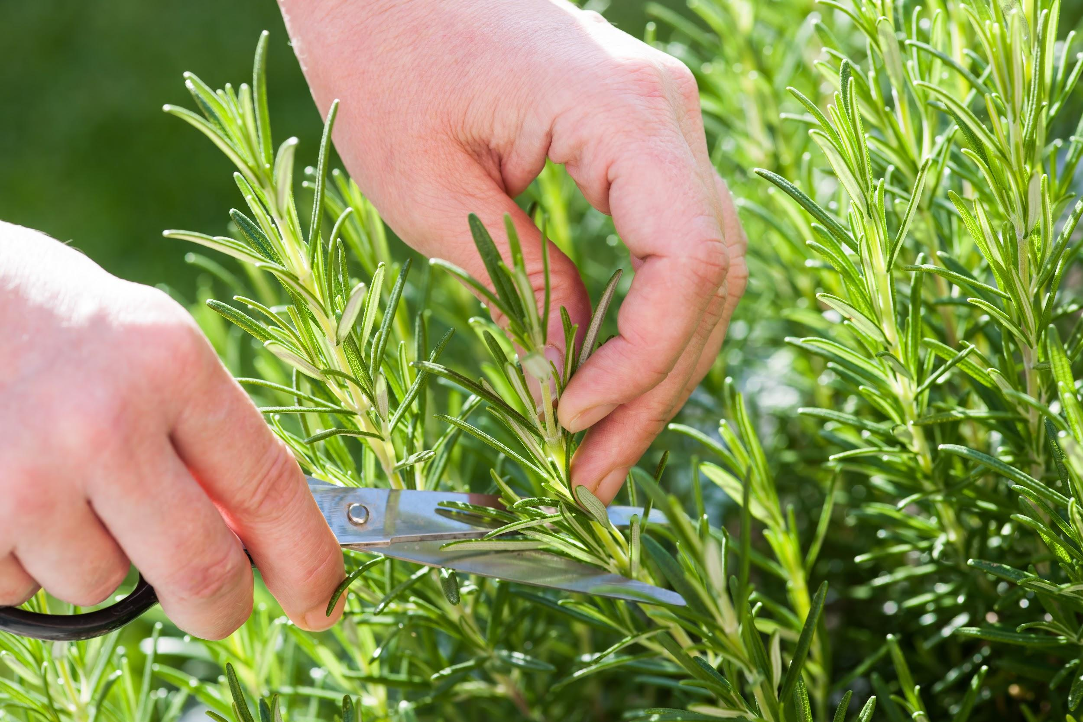

Harvesting regularly will encourage fresh growth, so don’t be shy about pinching and clipping your homegrown herbs.

Pick off the tips off each stem - about the top inch or two (depending on the size of the herb) to avoid tall, lanky plants. New shoots will grow from each stem, creating a fuller plant.

**Herbs to try - our top ten**

You can grow all your favourite herbs in a garden4me raised planter but here’s our top ten recommendations – chosen for how easy they are to grow, and for how useful and versatile they are in the kitchen

**Basil** - a key ingredient in many recipes, especially summer salads and Mediterranean classics, basil is Britain's most widely sold herb. 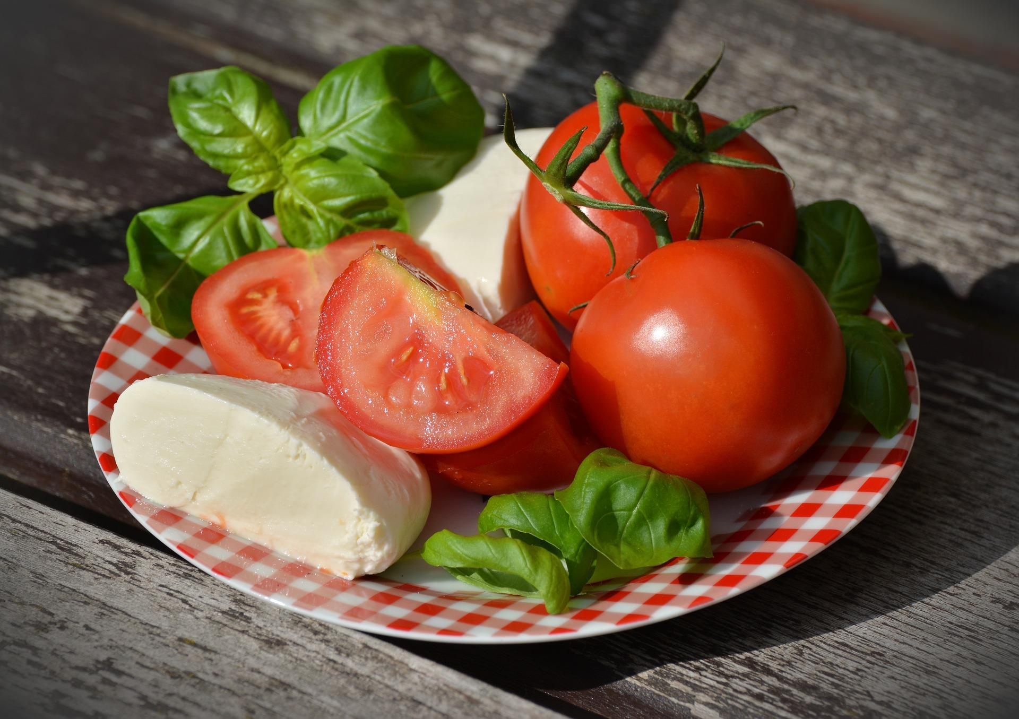

Basil is a tender annual, unable to withstand cold weather and frost and can only be grown outdoors in the summer.

Give it as much sun as possible. Pinch out growing tips to encourage bushiness and delay flowering, though regular sowings are still needed for a summer-long supply.

Leaves should be picked during the growing season and used fresh or dried (see Preserving Herbs later).

**Bay -** known for its pungent leaves which are used to flavour a wide range of dishes - it also boasts attractive ornamental good looks.

Bay lends itself well to growing in our garden4me raised planters as the deep growing bed gives its roots plenty of space to grow. Use it as the centrepiece for your herb garden for maximum impact and trim to shape in the summer.

Leaves should be picked during the growing season and can be used fresh or dried (see Preserving Herbs later).

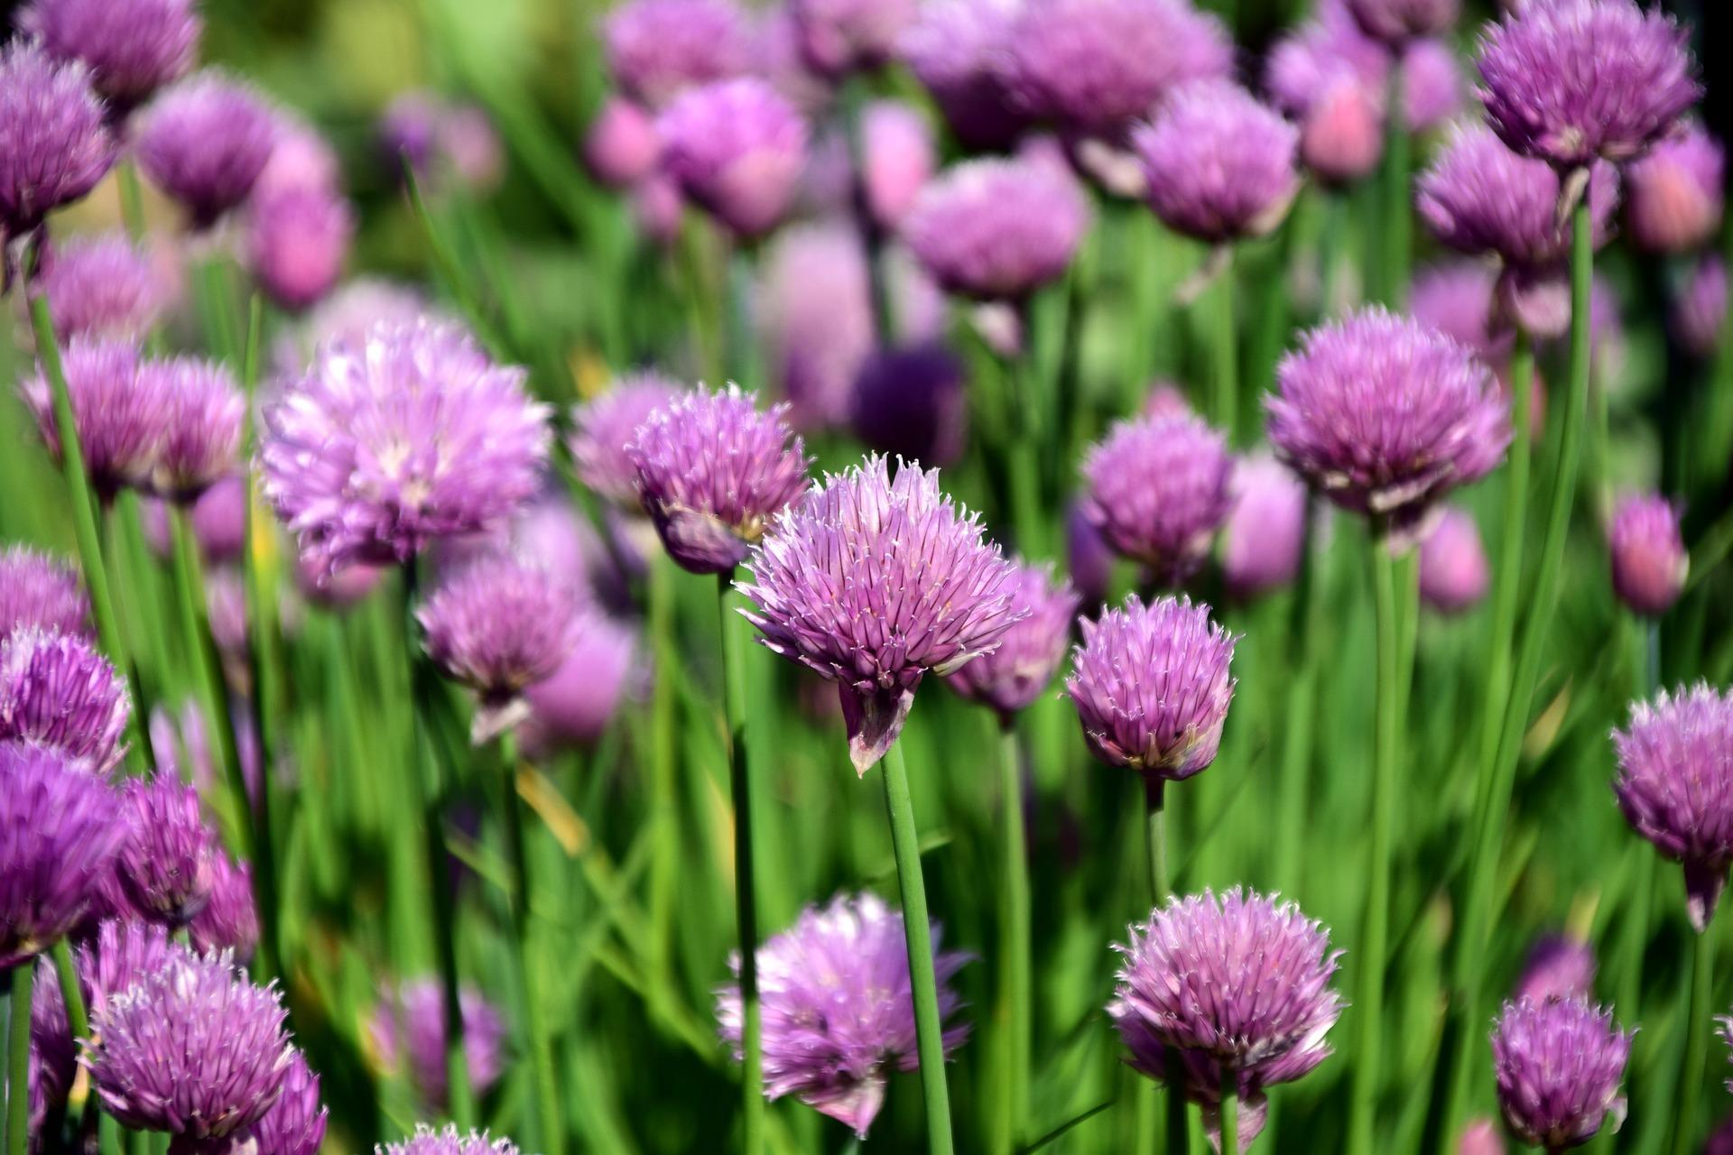

**Chives** - with their light onion flavour can be used in all sorts of dishes – from the classic potato salad, to soups and omelettes.

Chives love a sunny spot – they’re a low-maintenance, hardy perennial and especially easy to grow. Chives will be a superb addition to your raised planter- and have pretty, purple blossoms – which bees love.

Cut down after flowering to produce fresh leaves.

**Dill -** fresh and dried dill leaves, with their wonderfully aromatic smell, pair beautifully with seafood. The herb is also popular matched with potatoes and soups.

A short lived but hardy annual, dill can be grown from seeds in your raised planter. Dill hates having its roots being disturbed or being transplanted so sow direct into your planter. Start seeds off any time from mid-spring – or earlier if planting under a garden4me polytunnel.

Cut leaves as required during spring and summer. They can either be used fresh or frozen and dried for use over winter.   
  
Picking young leaves regularly will help to keep plants productive and delay flowering.



**Mint** – with its refreshing and pleasant flavour is often used to flavour salads and mint sauces as well as a useful addition to summer drinks such as Pimm’s and Mojito’s. Its leaves can also be dried or used fresh to create herbal tea.

Mint is a fantastically hardy perennial herb that is easy to grow – with light purple blossoms from August to September.

Mint likes plenty of moisture – which it will get from the reservoir – and plenty of sun. It’s particularly greedy though and will exhaust the compost eventually so we advise you grow in one of the garden4me growing pockets to confine it and then divide once a year.

**Oregano** – is an important herb in Italian and Greek cooking - often used dried rather than fresh in strongly flavoured dishes in which ingredients such as chilli, garlic, tomatoes, onions, olives and wine predominate.

Oregano is a perennial herb that loves the sun and a well-drained compost which makes it ideal for the raised planter as it will just take up the water it needs.

It can be bought as ready-grown plants from garden centres or grown from seed. Seeds can be sown from February (if growing under a garden4me polytunnel) to May.

Pick leaves before the flower buds open. Either use fresh, or dry and freeze for use later.

**Parsley -** one of the most popular herbs in British cooking, parsley is an absolute must to grow in your garden. Grown as an annual for its flavoursome leaves that are used as a garnish or in sauces, butters, dressings and stuffings. 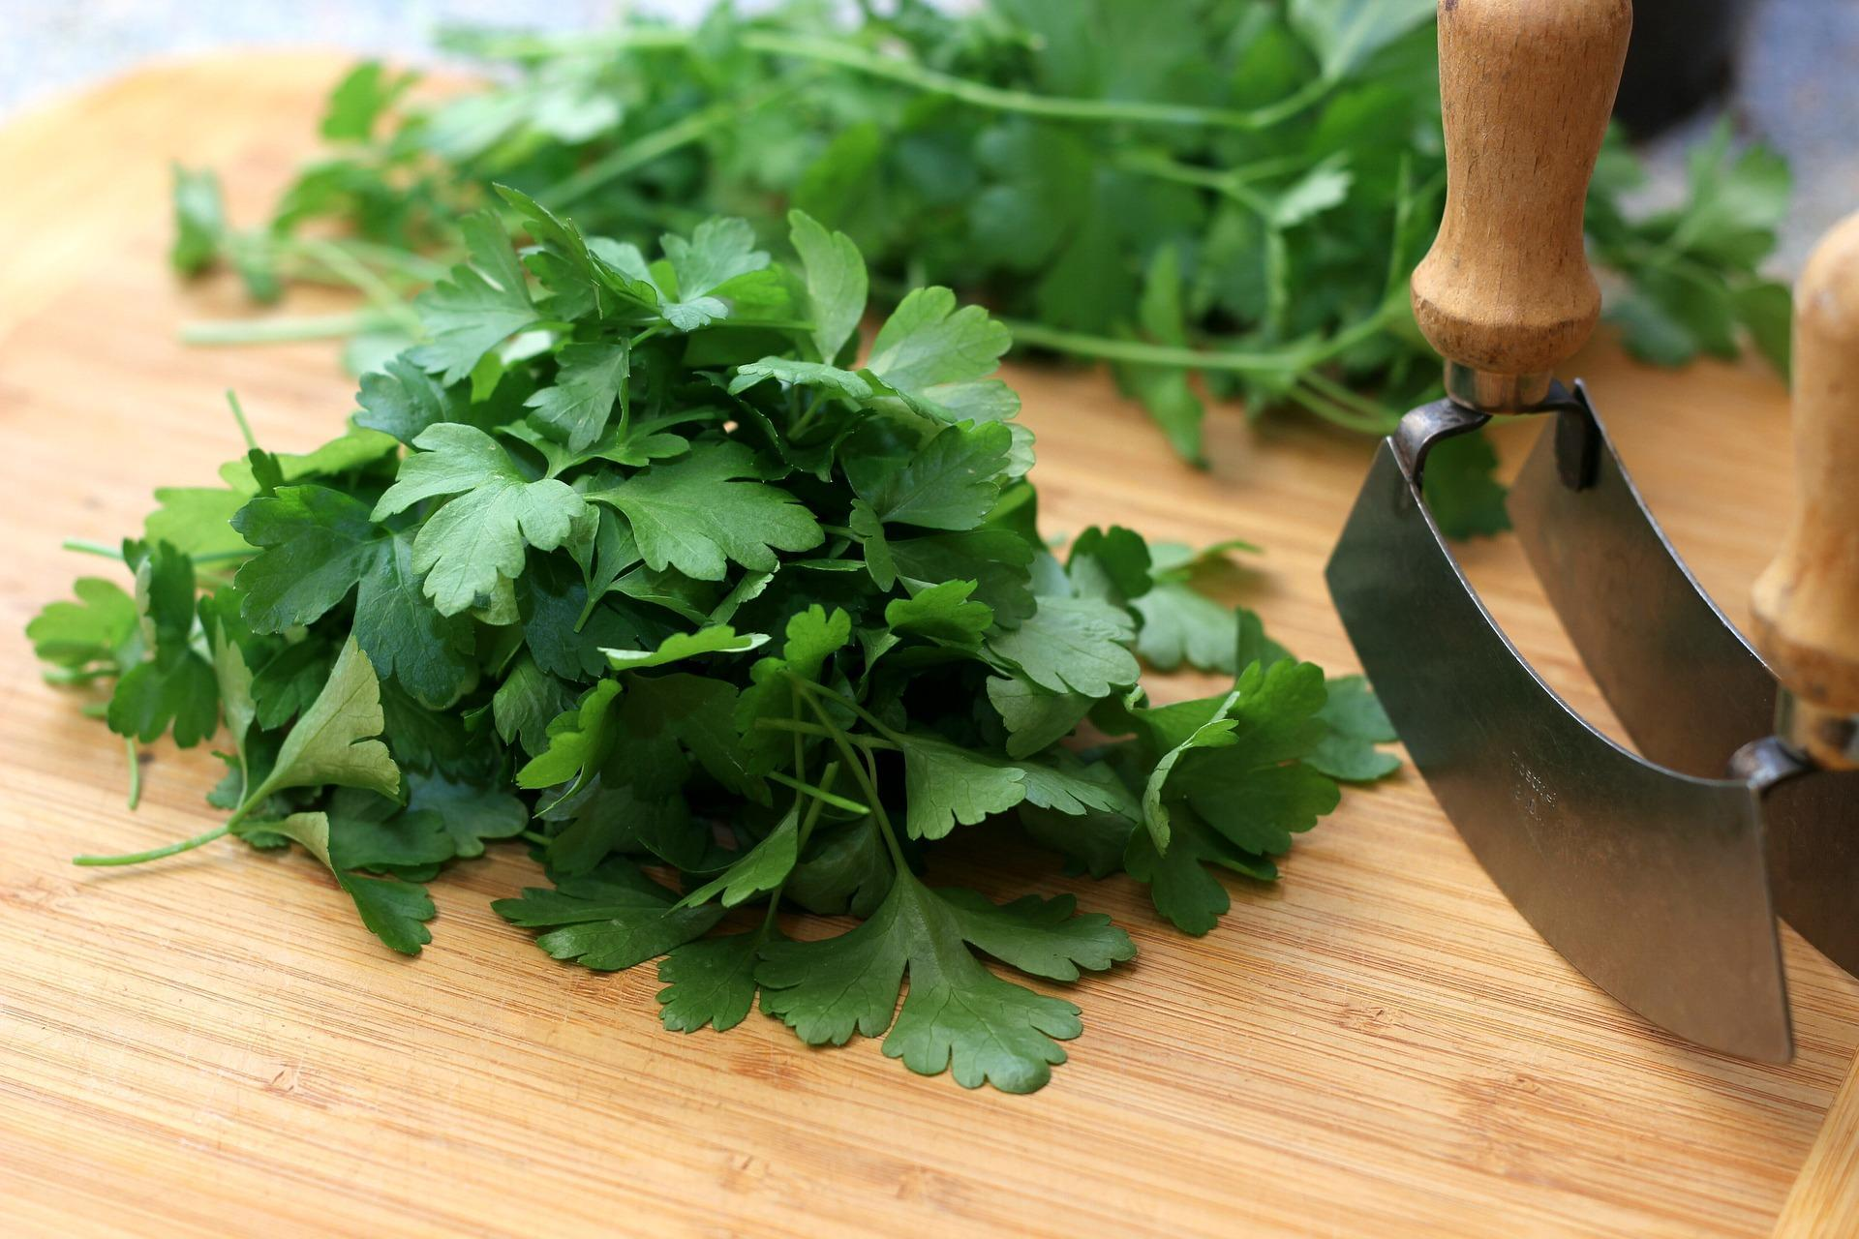

Sow direct into your planter from spring to early summer. Prevent from becoming unsightly and encourage new growth by snipping off any shoots that turn yellow.

Parsley can be used fresh and can also be frozen or dried (see Preserving Herbs later).

Carrot fly is a common problem for parsley but not if you’re growing in a garden4me planter - standing at over 10 inches from the ground means the threat of Carrot Fly is diminished significantly.

**Rosemary** - perfect with roast meats such as lamb and used to flavour many other dishes. As an evergreen shrub, its fragrant needle-like leaves are available fresh all year so it can continually grace your table and fill your raised planter.

Rosemary is best started in the spring from ready-grown plants. To keep plants compact, cut back stems after the blooms start to fade or plants will become leggy.

Can be used both fresh or dried - while sprigs steeped in olive oil give it a distinctive flavour (see Preserving Herbs later).

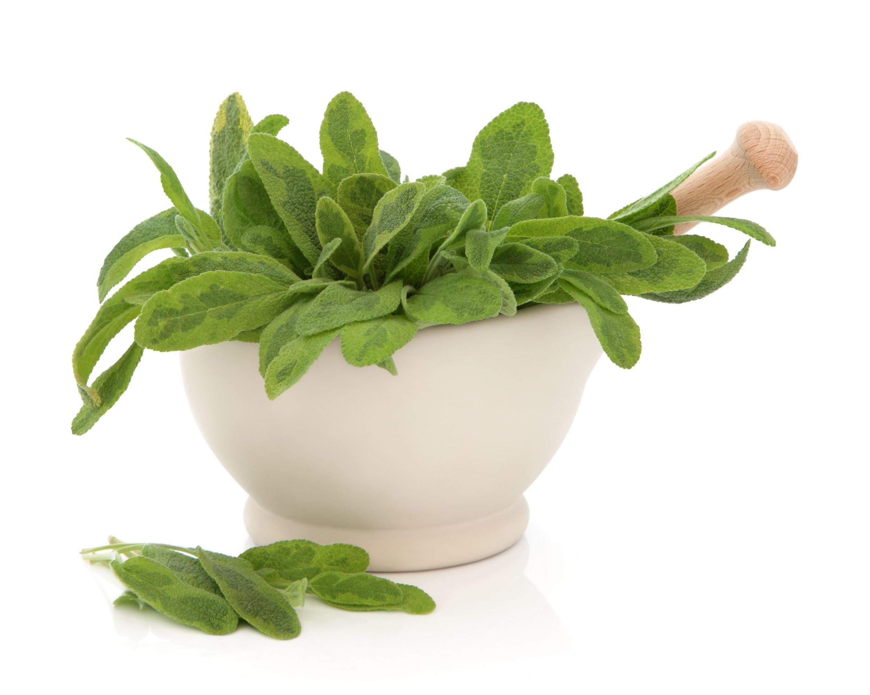

**Sage -** the intense flavour of sage makes it one of the most widely used and grown herbs in Britain – often paired with pork and used in stuffing. Unusually, sage's flavour increases as its leaves grow, meaning larger leaves can be used to create tasty dishes as well as small.

Its variegated and purple forms give great sources of colour for your raised planter and can double as an ornamental plant.

Sage is normally bought as ready-grown plants but you can grow from seed or take cuttings – although this will mean a longer time until you have plants ready to harvest.

As an evergreen shrub its leaves can be picked at any time for adding fresh to dishes. Excess leaves can be dried or frozen (see Preserving Herbs later).

**Thyme -** its edible leaves are used fresh or dried to flavour soups, stews, fish, meat, sausages, stuffings and vegetable dishes – and are a vital ingredient in bouquet garni.

Thyme will fill the air with scent on a warm sunny day, while its flowers are a magnet to wildlife.

Thyme can be bought as ready-grown plants but is also easy to grow from seed. Clip to shape after flowering.

As they are evergreen, thyme leaves can be picked all year round. Use scissors to snip off sprigs, ensuring cuts are made carefully to avoid spoiling the shape of plants. Use fresh or dried for later use.

**Preserving herbs**

Your garden4me planter will give great results so you’ll find you have plenty of herbs to use for yourself, your friends and neighbours – and still some left over! It’s very little bother to preserve the excess herbs you’ve grown – but different techniques suit some herbs better than others so here are our tips:

**Drying** – bay leaves, rosemary, thyme, sage.

Pick sprigs shortly before the plants start flowering, dip small bunches briefly into boiling water first, then very cold water, then hang up to dry in an airy place out of direct sunlight. When the leaves are crisp, crumble them away from the stalks and store in dry jars in a dark cupboard.

Dry lavender flowers of any fragrant variety on a flat tray in an airy spot indoors, then crumble the dry flowers to separate the florets and use to make lavender bags to put in the airing cupboard and drawers.

**Freezing** – for soft annual and perennial herbs, especially chives, tarragon, mint or parsley.

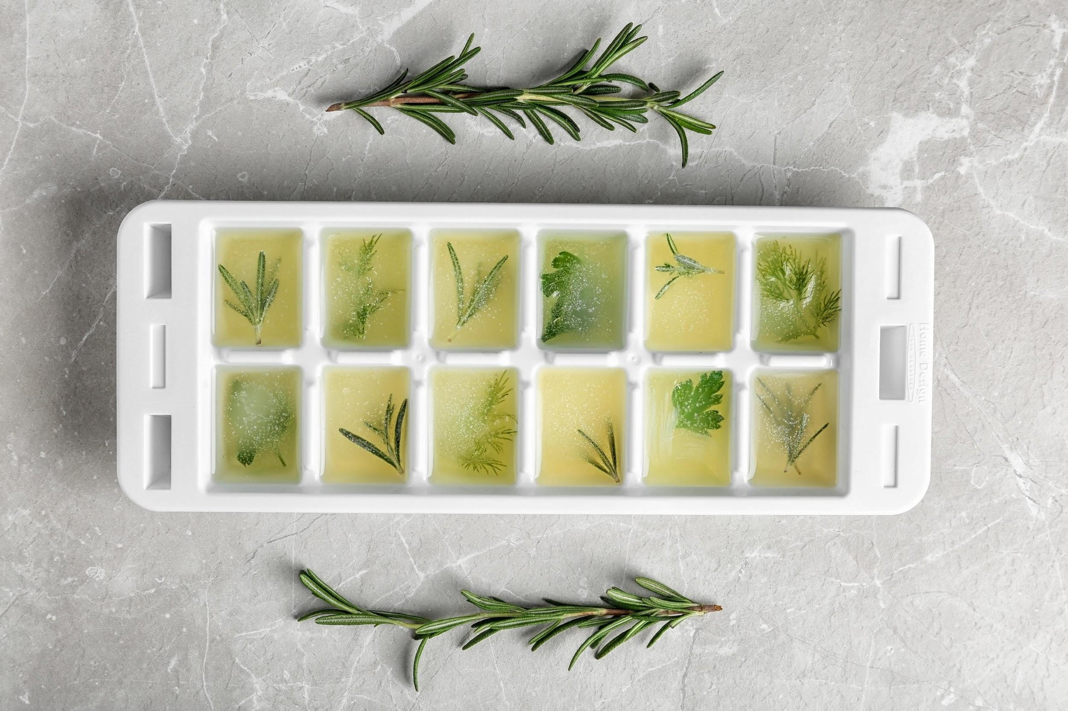

Chop washed herbs finely after shaking off the water, then mash with softened butter to freeze as herbal butter pats or pack them into ice-cube trays and cover with water.

Then they are ready to use instantly.

Make a glut of basil into pesto by mixing chopped leaves with grated Parmesan cheese and olive oil, then freezing in plastic containers.

**Make flavoured oil** – with soft annual aromatic herbs, especially basil, chervil or coriander.

Pack chopped leaves in screw-top jars filled with good olive oil and keep in the fridge to use by the spoonful with pasta etc. Make up a pretty sprig of mixed Mediterranean herbs including bay, rosemary and sage then put inside a bottle of olive oil. This will look pretty in the kitchen and it makes a great gardening gift.

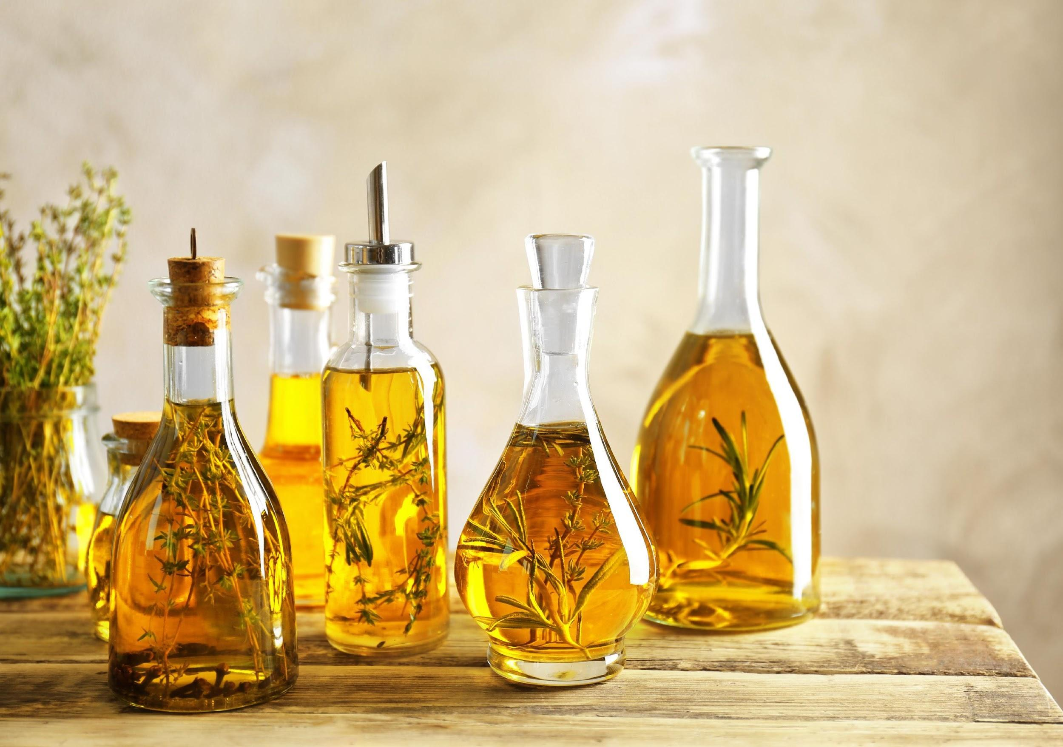

We hope you’ve enjoyed reading about herbs and how to grow in your garden4me raised planter - please check our website for further factsheets and information.